TIC TAC TOE
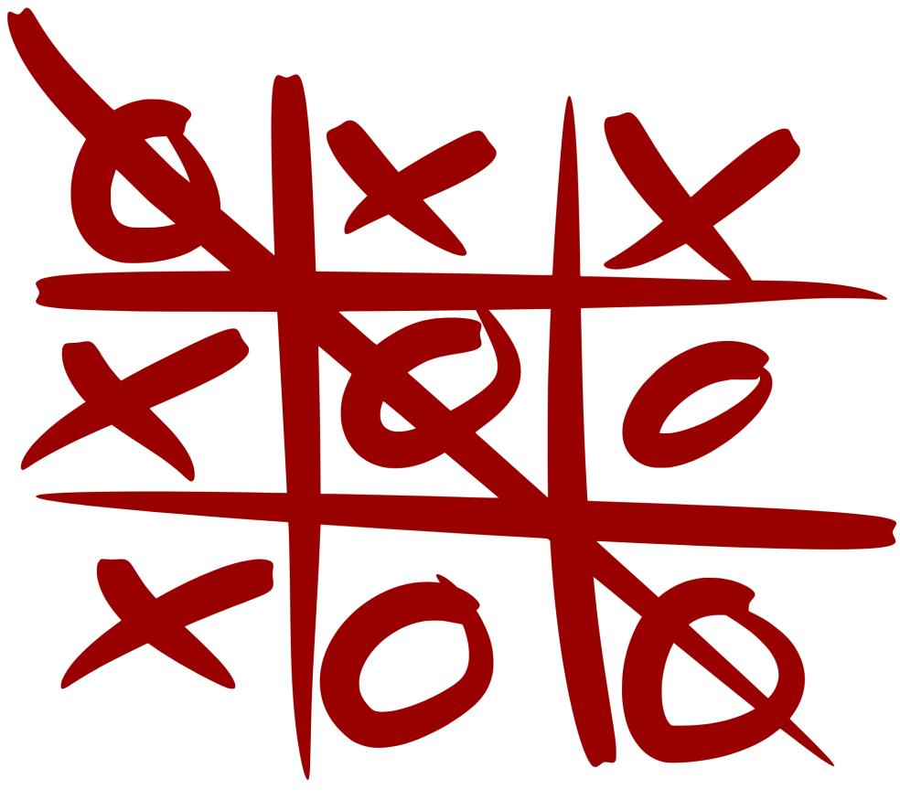

Introduction
I choose TIC TAC TOE (also known as Noughts and Crosses) since virtually everyone knows the game and the rules are simple enough that I don’t have to elaborate analysis of game configurations.
Despite being a simple game, the logic principle used in this game can be applied to more complicated game like Checkers, Connect 4, and even Chess.

TABLE OF CONTENT

- USERS OF THE SYSTEM
- FRONT END DESIGNING
- DATABASE
- FUNCTIONALITIES
- IMPLEMENTATION
- HARDWARE REQIREMENT
- SOFTWARE REQUIREMENT
- CODING
- APPLICATION OF SOFTWARE
- CONCLUSION
- REFERENCES

USERS OF THE SYSTEM:

**Player 1 and Player 2
- 2 Players will play the game.
- Game will be started by player 1 (by default)
- Player 1 starts the game.
- Makes a move and will place a marker (X) on the board.
- After player 1 made a move, second player will get the chance. Player 2 will make the move by playing marker (0) on the board.
- Both the player marks consecutively for 3 times.
- Then the game is over.

FRONTEND DESIGNING

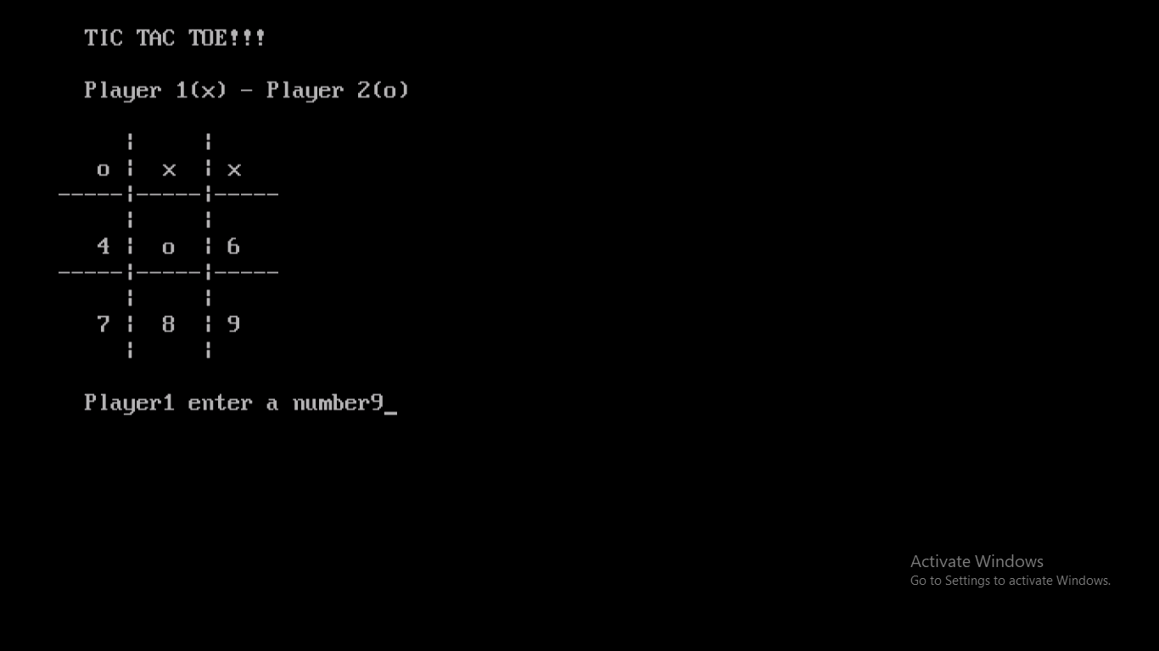
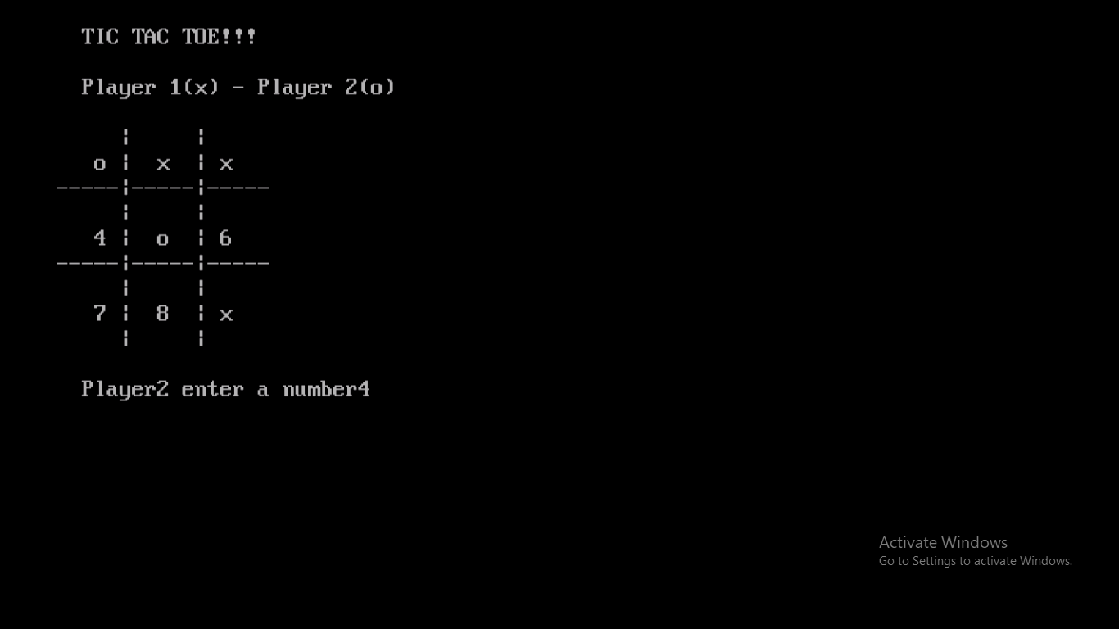

DATABASE:

NO. OF MATCHES | PLAYER 1 |  | PLAYER 2
 | WIN | LOSE | WIN | LOSE | DRAW
GAME 1 | ☑ |  |  | ☑
GAME 2 |  |  |  |  | ☑
GAME 3 |  |  | ☑
GAME 4 | ☑

The above table shows the database of result of matches held betIen the players.
Two times PLAYER 1 WON. One time the match result was DRAW. One time Player 2 won.

FUNCTIONALITIES:
Functions used in my program are:-
- Guide()-
The guide function will tell us all the rules to be folloId while playing the game.
- Board()-
The board function will display the board.
- Checkwin()-
The checkwin function will check who has won the game by returning 0 and 1 after the game.

IMPLEMENTATION:
- SOFTWARE REQUIREMENT
Turbo C is a discontinued Integrated Development Environment and compiler for the C programming language from Borland. First introduced in 1987, it was noted for its integrated development environment, small size, fast compile speed, comprehensive manuals and low price.

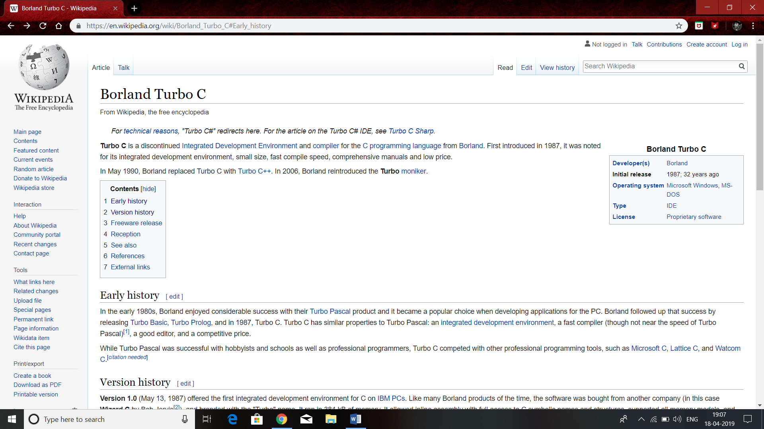

HARDWARE REQUIREMENT

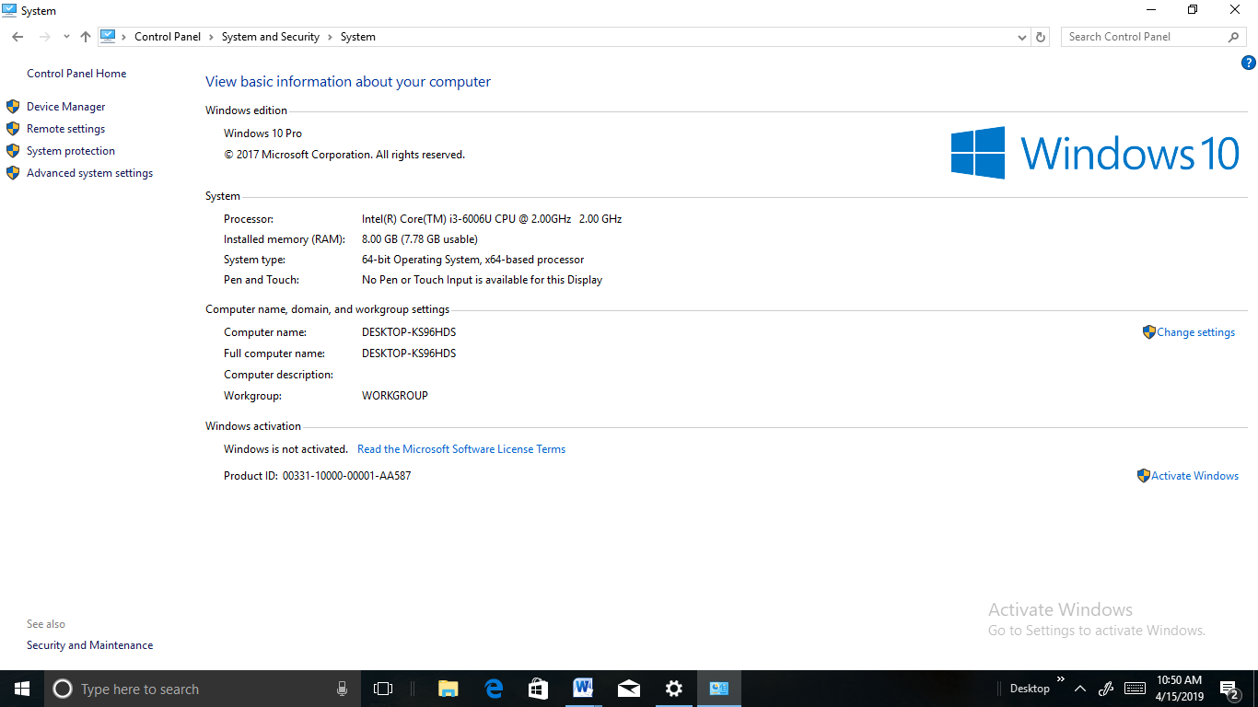

CODING:
#include<iostream.h>
#include<conio.h>
char square[10]={'o','1','2','3','4','5','6','7','8','9'};
void main()
{
start:
clrscr();
//TIC TAC TOE GAME
//SO LETS BEGIN THE GAME
int ch,choice,player=1,i;
char mark,c;
void guide();
int checkwin();
void board();
cout<<"ILCOME TO THE GAME"<<endl;
cout<<"MENU"<<endl;
cout<<"1.Playing guide"<<endl;
cout<<"2.Play game"<<endl;
cout<<"3.exit"<<endl;
cout<<"ENTER Ymy OPTION";
cin>>ch;
switch(ch)
{
case 1:
guide();
cout<<"ENTER 'y' TO RETURN TO MAIN MENU";
cin>>c;
goto start;

case 2:
do
{
// FOR MAKING BOARD
board();
player=(player%2)?1:2;
cout<<"Player"<<player<<" enter a number";
cin>>choice;
mark=(player==1)?'x':'o';
if(choice==1 && square[1]=='1')
square[1]=mark;
else if(choice==2 && square[2]=='2')
square[2]=mark;
else if(choice==3 && square[3]=='3')
square[3]=mark;
else if(choice==4 && square[4]=='4')
square[4]=mark;
else if(choice==5 && square[5]=='5')
square[5]=mark;
else if(choice==6 && square[6]=='6')
square[6]=mark;
else if(choice==7 && square[7]=='7')
square[7]=mark;
else if(choice==8 && square[8]=='8')
square[8]=mark;
else if(choice==9 && square[9]=='9')
square[9]=mark;
else
{
cout<<"Invalid Move";
player--;
}
i=checkwin();
player++;
}while(i==-1);
if(i==1)
cout<<" PLAYER "<<--player<<" WIN!!!!";
else
cout<<" *GAME DRAWN*";
cout<<"ENTER 'y' TO RETURN TO MAIN MENU"<<endl;
cin>>c;
if(c=='y')
goto start;

case 3:
cout<<"WOULD YOU SURELY WANT TO EXIT??"<<endl;
cout<<"PRESS 'y' FOR YES AND 'n' FOR NO"<<endl;
cout<<"ENTER Ymy CHOICE :"<<endl;

cin>>c;
if(c=='y')
cout<<"**THANKS FOR PLAYING**";
else
goto start;
}
getch();
}
void guide()
{
clrscr();
// game has the following rules which you should keep in mind while playing this game";
cout<<"1.Each block is defined by numbers 1 to 9";
cout<<"2.For winning this game"<<endl;
cout<<"x | x | x "<<'\t'<<" o | o | o "<<endl;
cout<<"---|---|---"<<'\t'<<" ---|---|---"<<endl;
cout<<" | | "<<'\t'<<" | | "<<endl;
cout<<"---|---|---"<<'\t'<<" ---|---|---"<<endl;
cout<<" | | "<<'\t'<<" | | "<<endl;
cout<<" OR "<<endl;
cout<<" x | | "<<'\t'<<" o | | "<<endl;
cout<<"---|---|---"<<'\t'<<" ---|---|---"<<endl;
cout<<" x | | "<<'\t'<<" o | | "<<endl;
cout<<"---|---|---"<<'\t'<<" ---|---|---"<<endl;
cout<<" x | | "<<'\t'<<" o | | "<<endl;
cout<<" OR "<<endl;
cout<<" x | | "<<'\t'<<" o | | "<<endl;
cout<<"---|---|---"<<'\t'<<" ---|---|---"<<endl;
cout<<" | x | "<<'\t'<<" | o | "<<endl;
cout<<"---|---|---"<<'\t'<<" ---|---|---"<<endl;
cout<<" | | x "<<'\t'<<" | | o "<<endl;
cout<<" OR "<<endl;
cout<<" | | x "<<'\t'<<" | | o "<<endl;
cout<<"---|---|---"<<'\t'<<" ---|---|---"<<endl;
cout<<" | x | "<<'\t'<<" | o | "<<endl;
cout<<"---|---|---"<<'\t'<<" ---|---|---"<<endl;
cout<<"x | | "<<'\t'<<" o | | "<<endl;
cout<<" OR "<<endl;
cout<<" | | x "<<'\t'<<" | | o "<<endl;
cout<<"---|---|---"<<'\t'<<" ---|---|---"<<endl;
cout<<" | | x "<<'\t'<<" | | o "<<endl;
cout<<"---|---|---"<<'\t'<<" ---|---|---"<<endl;
cout<<" | | x "<<'\t'<<" | | o "<<endl;
cout<<" OR "<<endl;
cout<<" | | "<<'\t'<<" | | "<<endl;
cout<<"---|---|---"<<'\t'<<" ---|---|---"<<endl;
cout<<" | | "<<'\t'<<" | | "<<endl;
cout<<"---|---|---"<<'\t'<<" ---|---|---"<<endl;
cout<<"x | x | x "<<'\t'<<" o | o | o "<<endl;
cout<<" OR "<<endl;
cout<<" | x | "<<'\t'<<" | o | "<<endl;
cout<<"---|---|---"<<'\t'<<" ---|---|---"<<endl;
cout<<" | x | "<<'\t'<<" | o | "<<endl;
cout<<"---|---|---"<<'\t'<<" ---|---|---"<<endl;
cout<<" | x | "<<'\t'<<" | o | "<<endl;
cout<<" OR "<<endl;
}
void board()
{
clrscr();
cout<<" TIC TAC TOE!!! "<<endl;
cout<<" Player 1(x) - Player 2(o)"<<endl;
cout<<endl;
cout<<" | | "<<endl;
cout<<" "<<square[1]<<" | "<<square[2]<<" | "<<square[3]<<endl;
cout<<"-----|-----|-----"<<endl;
cout<<" | | "<<endl;
cout<<" "<<square[4]<<" | "<<square[5]<<" | "<<square[6]<<endl;
cout<<"-----|-----|-----"<<endl;
cout<<" | | "<<endl;
cout<<" "<<square[7]<<" | "<<square[8]<<" | "<<square[9]<<endl;
cout<<" | | "<<endl;
}
int checkwin()
{
clrscr();
if(square[1]==square[2] && square[2]==square[3])
return 1;
else if(square[4]==square[5] && square[5]==square[6])
return 1;
else if(square[7]==square[8] && square[8]==square[9])
return 1;
else if(square[1]==square[4] && square[4]==square[7])
return 1;
else if(square[2]==square[5] && square[5]==square[8])
return 1;
else if(square[3]==square[6] && square[6]==square[9])
return 1;
else if(square[1]==square[5] && square[5]==square[9])
return 1;
else if(square[3]==square[5] && square[5]==square[7])
return 1;
else if(square[1]!='1' && square[2]!='2' && square[3]!='3' && square[4]!='4' && square[5]!='5' && square[6]!='6' && square[7]!='7' && square[8]!='8' && square[9]!='9')
return 0;
else
return -1;
}

APPLICATION OF SOFTWARE
- Tic tac toe is one of the significant game, which is being played back among the game folloIrs. It leads the market opportunity to the game developers in the country. my team of tic tac toe game developers and programmers strive to give you best tic tac toe game software in terms of quality.

- BR Softech is a top rated mobile game app Development Company and a Ill-known name in the gaming industry. Experience the expertise of my Tic Tac Toe software providers who develop UI for the multiplayer tic tac toe Ibsite or applications. Hire tic tac toe game developers as they have rich experience in the development of the best online games for multifarious clients in the world.

- I have an extraordinary team of expert tic tac toe game developers. my team of professional game developers excels in providing with the valuable feature game in IOS, android and other platforms.

- Business strategy is often like a chess; complex rules, practically infinite variations ,many complex patterns, difficult to master…the complexity of chess can easily obscure the points about strategy, so let’s use another game as a model for understanding the use of business strategy : tic tac toe

- Business strategy is about moving swiftly and getting an advantageous position in tic tac toe this is pretty straight forward

CONCLUSION
In the end I would like to conclude that my aim to make this project was to research in the field of AI development and implementation of Artificial Intelligence by developing the logic of the game. Some scope of improvements are also there in the project which will rectified in the future advancements of the project. I would like to thank all those who have helped us and contributed in making this project.

REFERENCES

- GOOGLE
- WIKIPEDIA
- DEVELOPERINSIDER.COM
- WWW.BRSOFTECH.COM

